August 2026
Editorial
It’s not long to go now until the Rally being held this year at Reading on 19th September. We hope many will attend the Rally and I would remind you that booking forms need to be submitted to Reading by 31st August. There’s a link for the booking form in this newsletter.
I’m sure many of you will have been out and about to rallies as has FMES for which there are reports included. Please read and consider Bob Polley’s comments about FMES representation at shows. Bob, in particular, travels many hundreds of miles each year to promote model engineering at shows. It will be good to spread that load.
FMES has previously published some initial guidance about Martyn’s Law. The Government has now issued some more comprehensive guide notes which we describe and reference in this newsletter.
There is a nudge about feedback about the content on safeguarding published by FMES. It would be good to have some!
Finally, we were saddened to hear of the passing of Tony Knowles from Nottingham SME. Tony was a good friend of a number of clubs and the hobby as well as FMES.

Tony Lee

Chairman’s Chat
As I’m sure you are all well aware the only “national” model engineering exhibition that still exists is the Midland Exhibition held in October at the Warwickshire Event Centre. There are around the country several “regional” shows such as LowMex in East Anglia and new this year the shows at Statfold Barn and the Southwest show at Newton Abbot. I feel that it is imperative if these events are to continue and even grow that they are supported by us all. To this end the FMES has taken their stand to these events as well as some traction engine rallies and similar shows.
The FMES stand has consisted of backdrops, flags, tables with models all showing the wide range of model engineering activities as well as literature, leaflets, screens, etc with information for not just the existing model engineer but the public in general. The stand has been manned by Fed directors and members of the management team. While there were the occasional quiet spells the folk manning the stand have been kept busy answering questions ranging from technical ones from those already involved in the hobby, queries about how to start in the hobby and perhaps find and join a club, the public wanting a model explaining and much more besides. With the help of the available literature several young people have been encouraged to not just look at the hobby but to consider engineering as a career and further their studies to this effect. Thus, the stand and its stewards have hopefully furthered the knowledge and awareness of the hobby and engineering in general.
What of the future? A stand of this nature manned by knowledgeable model engineers attending events around the country can surely only be good for the hobby in that it will promote and hopefully help to sustain healthy membership levels in model engineering clubs as well as a general interest in the hobby. While it is hoped to be able to continue with the stand as already established it would be good if there could be a greater geographical spread of attendance at suitable events. Thus, it has been suggested that this might be achieved by having regional FMES representatives who would man, perhaps one or two times a year, a scaled down stand at events in their area. They could be supplied with suitable banners/flags, literature/leaflets, etc, show a few of their own models and generally promote the hobby in their region. The organisers of events usually supply tables/chairs in a covered location.
So, how about it? Would you be willing to be a regional Fed representative and help the FMES promote the hobby at suitable locations? OK, at this moment in time it is only a suggested way forward, but don’t think somebody else will do it, they also may think somebody else will do it and so we get nowhere. If you do think this idea is a good one and that you may be able to help, please get in touch.
Bob Polley

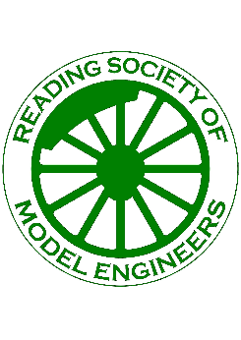
Federation of Model Engineering Societies
Saturday 19 September 2026
Hosted by the Reading Society of Model Engineers

The 2026 Federation rally is to be hosted by the Reading Society of Model Engineers at its Prospect Park Railway site on Saturday 19th September 2026.
The Reading Society of Model Engineers was first formed in 1910. The society is a charitable incorporated organisation (CIO) and occupies land leased from the local authority. Membership was just over 100 in 2025 with a subscription of just £20 annually. More details can be found on the club website https://www.rsme.uk/ or on Facebook at https://www.facebook.com/Prospect-Park-Railway-Reading-Society-of-Model-Engineers-304909433015879
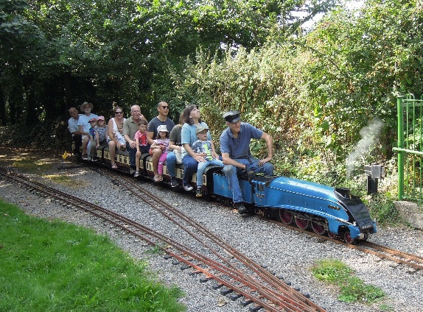
RSME is based at 82 Bath Road, Reading RG30 2BE. If using satnav enter “Prospect Park Railway”. The site is about a mile from the town centre situated on the A4 road going west and is situated in a pleasant park setting including spacious parking for vehicles. It includes a club house with catering facilities, a newly modernised workshop, and a 1,200 ft raised level miniature railway track incorporating 2 ½, 3 ½ and 5-inch gauges. This is surrounded by a 1,500 ft ground level track, with a gradient, incorporating 5 and 7 ¼ inch tracks.
Refreshments will be provided throughout the day together with a buffet lunch at mid-day
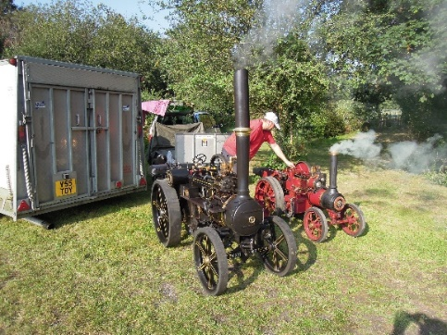
To assist the unloading of ground level locomotives a hydraulic lift is used giving access to a turntable and steaming bays. Both tracks have a 12/24 volt facility and are fully signalled provided the actuating club carriages are used. The ground level carriages have vacuum brakes which may be actuated by the locomotive ejector or by a vacuum pump on the carriage.
RSME members have a wide range of interests Including traction engines, clocks, vehicle restoration and workshop practice generally. The clubhouse also incorporates a 00-gauge model railway which is being continually developed by those of all ages.
The Annual FMES Autumn Rally Competition is open to any exhibit that evokes the spirit of model engineering. This may include locomotives, road vehicles, stationary engines and model railways. The judges will consider the degree of construction provided by the owner in arriving at an outcome.
Qualifying models will be judged by a member of the FMES, RSME, and a suitably qualified model engineer. The competition rules can be found at the FMES website HERE.
Alongside the FMES rally competition, there will be an opportunity for prototypical outline locomotives to be judged in line with the Australian Association of Live Steamers (AALS) rules. Entrance must be a working steam locomotive of a Commonwealth prototype in any gauge between 2 ½ and 7 ¼ inches. The AALS competition Rules and FAQs can be found HERE.
If you wish to see more about these competitions, please refer to the FMES website, in the appropriate section under EVENTS AND COMPETITIONS
Competition for the AALS trophy is open to all members of clubs and societies affiliated to FMES, and such members may nominate their locomotive for judging. If deemed appropriate, these may include other locomotives present on the day but not nominated.
You do not need to pre-book for these competitions; judges will consider all eligible models anyway!
Camping is permitted on site by booking only. Please contact stuartnkidd@aol.com. All waste must be taken away, as we do not have suitable waste disposal systems.
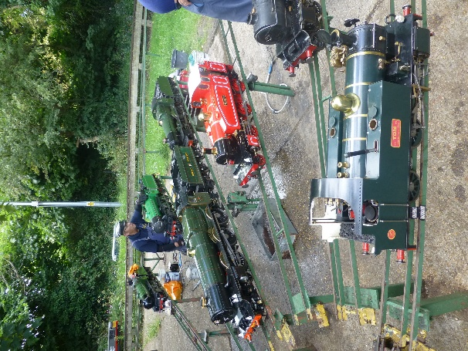

If bringing a steam locomotive or any model boiler to be used please remember to bring a current boiler certificate. Proof of club membership and insurance certificates are required for operating models at the rally.



2026 Competition Rules, Eligibility and Judging Criteria
Reading Society of Model Engineers
Saturday 19th September 2026
These rules are in addition to the overall rules and are relevant only for the 2026 rally.
- Any model locomotive or vehicle that can operate on either the raised or ground level tracks will be eligible to enter.
- Any miniature machine that can be accommodated and displayed on the premises, e.g. traction engines, etc
- Locomotives and other miniature machinery may be powered by any source. Rolling stock and any other machinery that was unpowered in full size will be eligible.
- The judges will be seeking fidelity to the prototype of any gauge or scale and of any country of origin. Ideally, the entries should be shown operating if possible.
- Entrants should be prepared to describe to the judges the prototype on which the model is based and to discuss the provenance of the model and the source of design or parts and details of construction, alteration and maintenance.
- Since it is difficult to be totally definitive in written rules, or there is any uncertainty about eligibility, please e-mail info@fmes.org.uk for guidance.
Other questions relating to entry e.g. unloading power requirements, security, or any local matter relating to the competition please contact RSMESecretary@rsme.uk

To access the booking form for the Rally, double click on the link below:

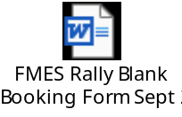
NB. Closing Date for Entries is 31st August

Martyns Law update July 2026
You may remember that we published an awareness raising guide to the above law in May 2025 (see the website HERE) describing the main aspects of this new requirement. It is due to take full force in April 2027 and this article is to provide some update to the previous information we published.
We will not reissue the original article as it is still relevant, however there are now more guide notes available from government and support agencies that may be of interest to member clubs.
The main source of information is:
https://homeofficemedia.blog.gov.uk/2025/04/03/martyns-law-factsheet/
This was updated in May 2026.
The agency that will manage the requirements of the Act is the Security Industry Authority: https://www.gov.uk/government/organisations/security-industry-authority
‘Protect UK’ is a government sponsored organisation that provides learning/information and other support for free: they now have more information on their website to assist. This can be found at:
https://www.protectuk.police.uk/martyns-law
Note that government do not endorse any third party products offered by private companies regarding this legislation, and there is no expectation that an organisation will need to spend money on consultants to comply.
There are further links on this ‘ProtectUK’ website to information that defines how to respond to the requirements (after April 2027). It includes, for example, the following:
- ‘One page leaflet’ explaining the responsibilities that organisations and/or individuals have when an activity (premises or event) qualifies for inclusion (for example, when more than 200 people are expected for an event at any one time).
- ‘Myth busting’ comments.
- Scope of the act
- Top tips
- Flowchart support for defining what is within scope.
Some of the points described by this link include (but not limited to, so please check for yourselves):
- From April 2027, qualifying organisations or events (ie those with at least 200 people expected to visit ‘premises’ at any one time) will need to have ‘public protection procedures’ in place covering evacuation or ‘invacuation’, lockdown and communication.
- For those premises or events with 800 or more people at any one time, this is added to by procedures covering monitoring, movement control, physical and information security.

- For all qualifying premises or events, the regulator (the Security Industry Authority, SIA) must be notified who is responsible for the premises or event. It appears that this might be an organisation not an individual.
- The question about what falls within the scope of the Act is described in the two flowcharts in the above link, covering separately ‘premises’ and ‘events’.
This legislation is not dissimilar to others in that it requires organisations that attract people (in sufficient numbers above two limits) to visit to take some steps to ensuring that there are procedures in place (and that have been appropriately communicated to the ‘staff’ who will have to carry them out) to support the security and safety of those ‘on site’.
It is important to keep the implications of this Act in perspective. The above link includes useful guidance including ‘mythbusting’ and a flow chart to decide if ‘your’ event or activity falls within the scope of the act.
FMES view is that some clubs might well fall under the requirements of the ‘standard tier’ owing to club premises and land being ‘secured access’ and membership plus visitor numbers might well top 200 people from time to time. It is unlikely that the 800 plus limit (at any one time) will apply except where a club holds a special event such as an exhibition etc, however each club must assess its own situation.
Note that as we have learned from a number of cases with other legislation, a landlord (particularly a public landlord such as a council) may take a different and maybe incorrect view of the compliance requirements with such legislation. We suggest that you prepare your processes in good time for the effective date of the Act: there may be circumstances where liaison with the landlord or other parties is important in deciding these processes (for example, where a club has many visitors that queue to enter club premises etc in a public park).
If you want to start from the beginning and source the links yourself, the government link covering this topic can be found at:
https://www.gov.uk/government/publications/the-terrorism-protection-of-premises-act-2025

Website Library
Did you know that the Library of documents on the FMES website has a section on workshop techniques? Here you will find many articles with hints and tips. These include machining, pipe work, techniques and tools. To remind you there is a list of articles recently entered into the library. These include progress on the old Rube project and the FMES AGM Safeguarding Workshop Report 2026. As always we welcome your contributions to the library.

Stoke Row Steam Rally, June 13/14th 2026
We seem to be developing a routine for going to this Steam Rally, both individually and as FMES – and for good reason!
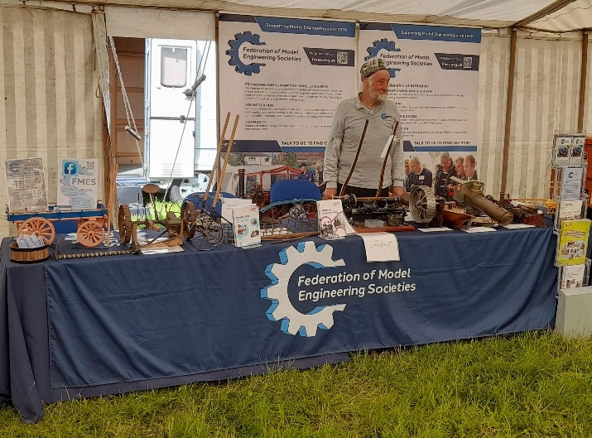
The weather gods blessed the event and a fine weekend brought many visitors and a really interesting selection of exhibits of all types. For the second year, we took along a stand and our brochures and enthusiasm to fulfil our ‘strategic intent’ of spreading the message of model engineering to the many general public visitors. For this type of show, we also try to exhibit some examples of model engineering across a broad spectrum, and this year we showed agricultural machinery models (which attracted a lot of visitors saying ‘I’ve got one of those’), a model boat, a steam locomotive and a part finished 1.5” scale traction engine mainly to show a boiler. We chose these to encourage visitors to see inner workings and development and they certainly helped attract and hold many people. The photo shows our indefatigable Chairman and the stand prior to opening time so you can see it!
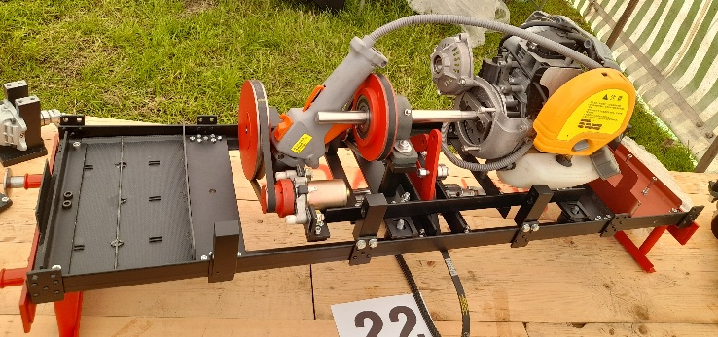
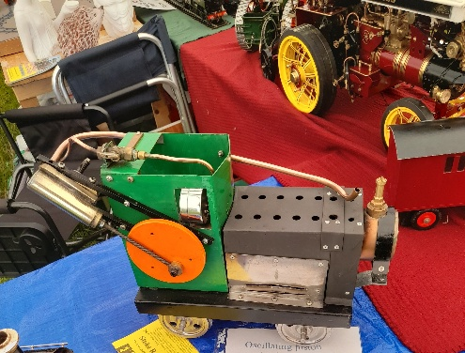
We were in the ‘model tent’ and this was also occupied by an extensive display from Reading SME, who of course are hosting our rally this year on September 19th. They had an excellent display of locomotives and other exhibits, with some unusual examples for interest.
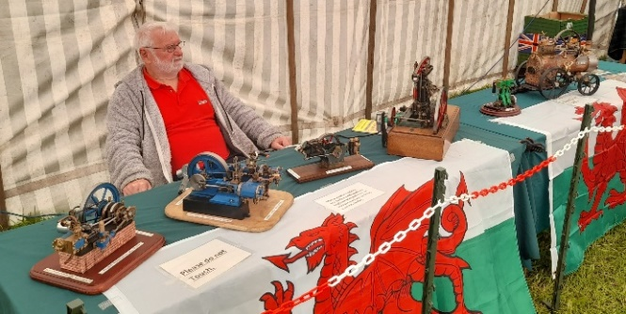
The model tent had some other high quality exhibits on show too from a number of model engineers, all of interest to visitors showing the breadth of model engineering, notably Kevin Gingell’s stand showing stationary engines, some powered by electric motors for movement.
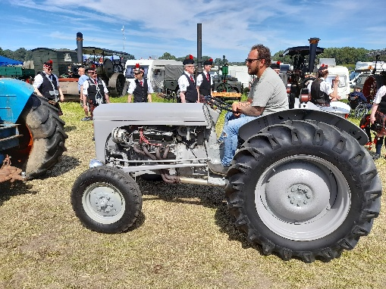
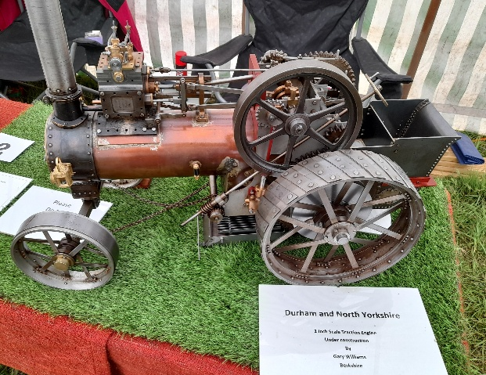
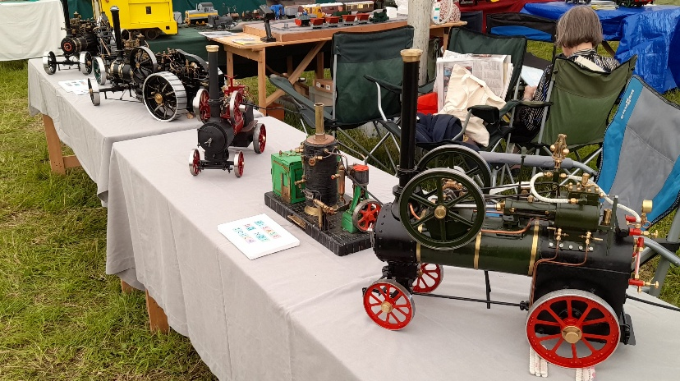
Whilst there were a number of larger scale miniature traction engines running around the rally field outside, the model tent had a good selection too:
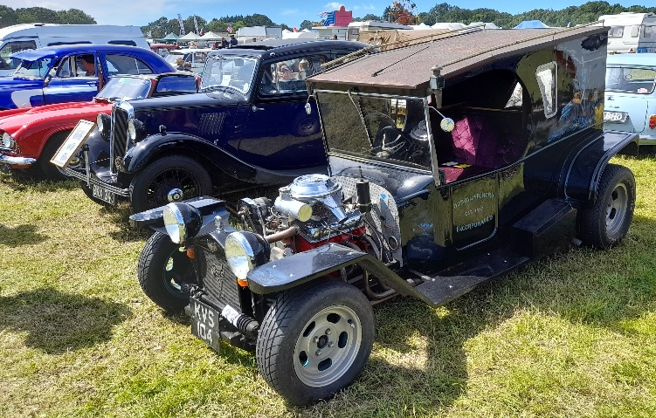
Outside, the rally showed off many other items of interest that were far too numerous to do justice to, but all of engineering interest. These included very many tractors of all ages including a Rover V8 powered ‘grey fergie’ that was certainly the loudest in the long procession around the arena (and probably the fastest 0 – 60mph?). Classic vehicles were also well represented from wacky to wonderful…
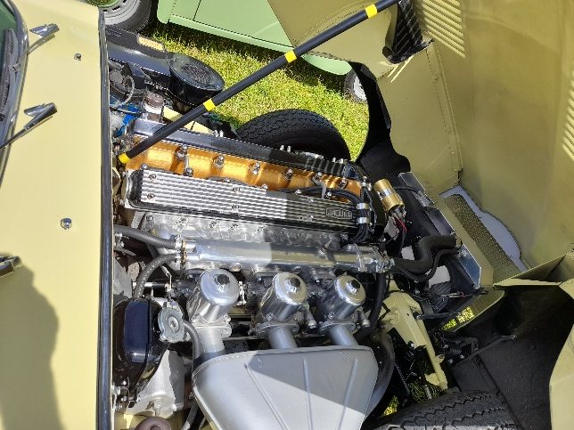
Bikes, powered and otherwise also had an excellent showing…
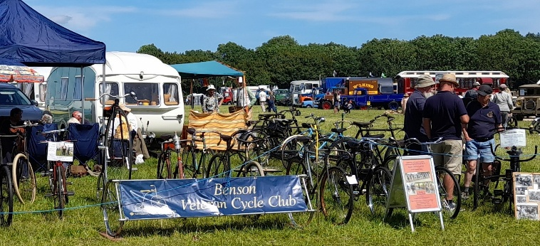
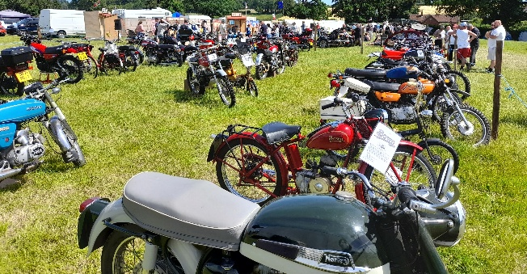

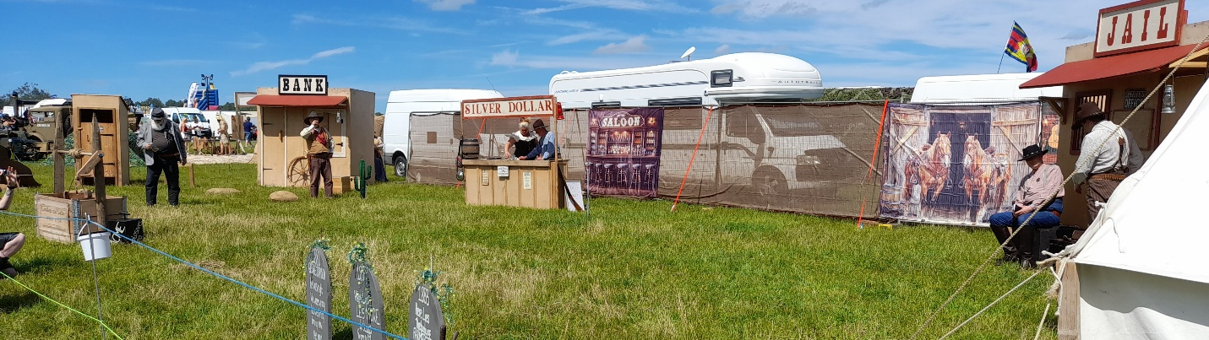
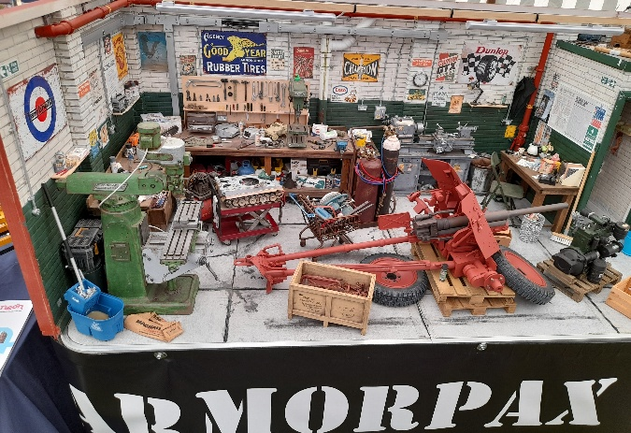
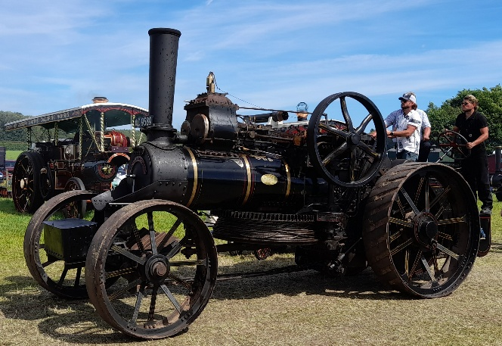
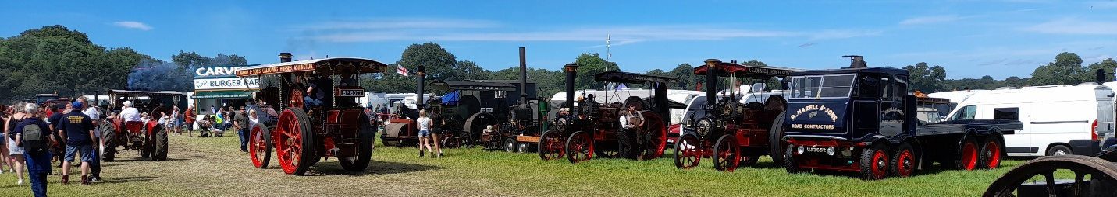
There were many other exhibits of course, impossible to do justice to in a brief article, suggesting that you would do well to look out for this event in future years and make a date to come, it is a good family event, not just for the afficionado and there were plenty of other attractions including fair rides, historic enactments, military vehicles, plenty of food and entertainment stands, market stalls and of course a beer tent. Here are a few photos to whet such an appetite:

As a last note, this year we have spent some time travelling more than usual to such events where public visitors are not restricted to ‘the converted model engineer’ but where there are people with a passing interest in such a wide variety of engineering linked topics and that might be engaged enough to pursue ‘our’ hobby. Indeed, our stand alone was instrumental in getting the attention of potential new hobbyists and club members, as well as providing an insight into engineering as a career for young people. We provided not a few brochures published by the engineering institutions regarding engineering as a career to parents and to young people, and that must be good for the country as well as the hobby. We are going to be discussing our stance next year to the attending of such shows, and for this we will desperately need more volunteers from our communities to man a modest ‘stand’ local to them to this end. Our thoughts include providing interested volunteers from our member clubs with a small ‘stand’ and brochures, to be supplemented with a few interesting exhibits. If you have any interest in this (modest expenses paid) please do let us know at info@fmes.org.uk!

SWEMES Show 15th-16th May
(South West England Miniature Engineering Show)

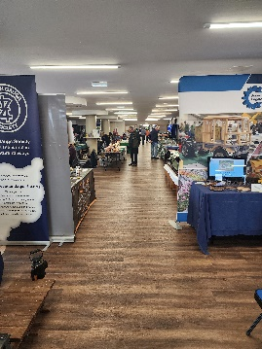
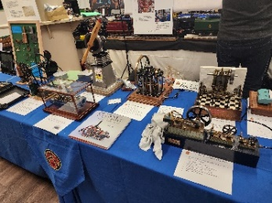
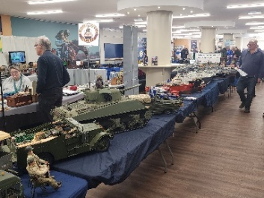
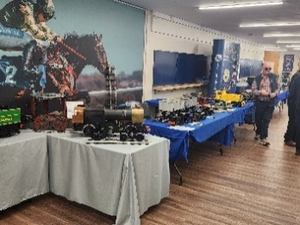
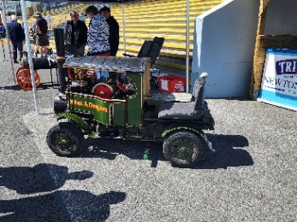
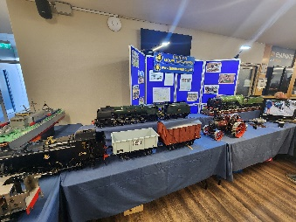
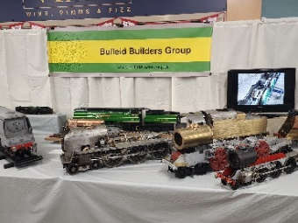
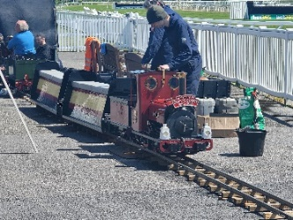
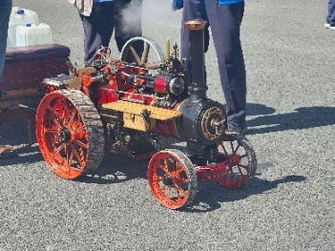
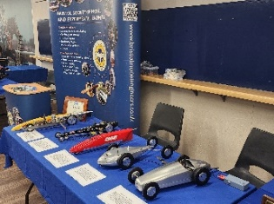
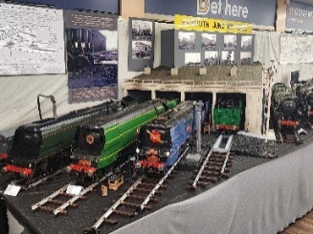
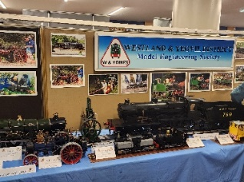
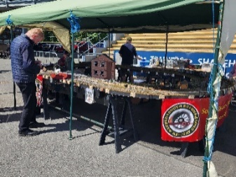
May 2026 saw the inaugural SWEMES Show held at Newton Abbot Racecourse, a new show that gives a platform for displaying model engineering, clubs and suppliers in the South West. As someone who lives in central England it’s easy to overlook the fact that when you get to Newton Abbot there’s still another 100 miles or so before you reach the end of Cornwall. It should therefore be no surprise that everyone I spoke to was enthusiastic to have a model engineering show closer to home.
Newton Abbot Racecourse was a good venue with good parking, plenty of room for club and supplier stands in the hospitality area under the main stand and a large tarmac area in front of the main stand giving plenty of room for the passenger carrying train and traction engines to operate. It was good to see clubs and models that don’t get to other shows further afield.

Rob Speare is to be congratulated in taking on the risk of promoting a new show. He and his volunteers succeeded in their aim and it should be acknowledged that it is a not-for-profit show intended to benefit local hospice charities.

Safeguarding
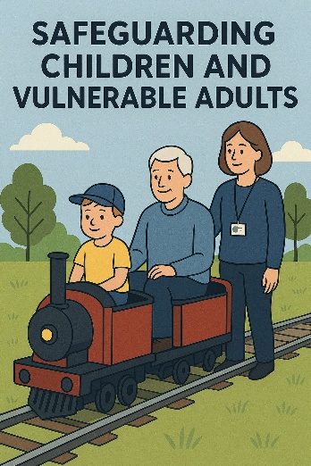
In the last newsletter, we asked clubs for their comments on our work so far on Safeguarding, and we were deafened by the silence. It seemed appropriate therefore to remind clubs that we can only decide whether to pursue any initiatives (not just Safeguarding) if we get appropriate comment and support.
Notwithstanding this nudge, we would also seek to hear from any club that has experiences with safeguarding to relate that might be of interest to other clubs, especially if this identifies potential pitfalls, things to avoid and things to do as well as setting out to discover ‘good practice’.
If you have anything to contribute on either of these aspects, please do not hesitate to contact us at info@fmes.org.uk .

Boiler Seminar
The Autumn 2026 FMES/NAME Seminar for Boiler Inspectors will be held on Saturday 14th November 2026, kindly hosted by the Leyland Society of Model Engineers
Their site is in Worden Park, Leyland PR25 1DJ. A map showing the location is available on their website Visiting Us | Leyland Society of Model Engineers
Places at the seminar are limited to 40 delegates, and are open to established boiler inspectors, those who regularly act as the witness and anyone interested in becoming an inspector.
Places must be reserved with info@fmes.org.uk
The seminar opens at 10.00 am and closes at 4.30 pm with a buffet lunch provided by the hosts.
For more information please contact secretary@fmes.org.uk


We would like to inform you of a change of name/rebranding of Walker Midgley (WM), the insurers for many of our clubs (and ourselves). The new name will be ‘Everywhen’ and this is now active, although some details (eg email addresses etc) may be updated in due course. It is very important to note that WM have the following explanation and confirmation: The rebranding is a replacement of the WM name and logo with Everywhen and the relevant logo. All the people in the office, contact phone numbers, address etc remains exactly as they are now. The tone of the rebrand is that it is very much business as usual, with the same people they have always dealt with, doing the same type of business with the same high level of service that they have always had. The web address, www.walkermidgley.co.uk will still work for a while with a divert to a new URL which is currently https://www.towergateinsurance.co.uk/walker-midgley .
Updates to insurance policies and other paperwork will follow in due course, but existing policies under the WM name will be otherwise unchanged.
If you have any questions for the insurers, please use the contact links above.
FMES Accounts
When paying the annual subscription or paying an invoice, the methods of payment are as follows:
1 - Preferred payment please is by BACS (On-Line Banking)
Federation of Model Engineering Societies
Lloyds Bank, Sort Code 30-99-50, Account No. 13328562
Remember to include your affiliation number as the reference.
OR
2 - By cheque made out to Federation of Model Engineering Societies
Please send the cheque to:
Mr. A. Lee, 6 Thatchers Close, Epwell, Banbury, Oxon, OX15 6LJ
Please include a note with your affiliation number or write it on the back of the cheque on the right hand side. If paying an invoice eg. for publications, please include the invoice number

The Federation Boiler Registrar
Copies of Written Scheme of Examination for the Boiler Registrar
I’ve had a few enquiries on the return of the pink slips for our records.
As most things are sent electronically these days, so I am happy to accept a copy of the Written Scheme of Examination by email or messenger. Please scan or take a picture of the white copy, as the pink slips are almost impossible to read from a picture
You can still send them by post if you prefer, I am happy with either method. However you send them to me, please make sure that the certificate is filled out correctly and all fields are populated.
Copies without Boiler Number, Owner, Model, Scale, Club Affiliation Number or Date cannot be registered and will be returned.
Thank you
Colin Walton
Missing Certificate set
We have a report from a member that a blank certificate set has gone missing from their pad.
Please watch out for certificate number C210459 as it might be used to support the sale of a model with an untested boiler.
Please be aware when purchasing a model or when a ‘new’ pressure vessel is introduced to your club.
Supplies of certificate pads etc.can be ordered using the SHOP page on the website:
https://fmes.org.uk/shop-2/
and the order will go direct to Colin, or you can contact him by email using colin.walton@fmes.org.uk or by phone on 07745 687159
His address for sending WSE forms is:
12 Lytham Road
Midandbury
Southampton
SO18 2BP
FMES Committee
President Brent Hudson
Vice President Mike Chrisp
Vice President Ivan Hurst
Chairman Bob Polley
Secretary Peter Squire
Treasurer TBA
Vice Chairman Paul Naylor
Safety Officer Robert Walker
Management Team: Peter Harrison, Jim Hollom, Peter Kenington,
Tony Lee, Melvyn O’Connell, Colin Walton
INSURANCE CLAIMS AND INCIDENTS
All claims and reports of incidents should be notified in the first instance to Walker Midgley
FEDERATION INSURANCE BUSINESS Managed by Walker Midgley Insurance Ltd
It will be useful if Clubs also advise FMES when an incident has been reported.
(Information held in confidence – internal use only)
info@fmes.org.uk
Publications Available from FMES
The FMES publications listed below are available from our stand at rallies and exhibitions or by post. Please make contact first by email, initially to info@fmes.org.uk or use the ‘shop’ option on the website. The figures below are for single items and do not include postage.
We will minimise postage costs for multiple items.
Please make cheques payable to ‘Federation MES’ or use BACS to Sort Code 20-71-82 Acct 43755967.
Examination & Testing of Miniature Steam Boilers BTC 2018 - Orange Book Free
Vol 1: 3 bar litres to 1100 bar litres; Vol 2: under 3 bar litres; Vol 3: LPG tanks under 250 ml.
Boiler Test Certificates - Pad of 50 FREE*
Written Scheme of Examination - Pad of 50 . FREE*
Small Boiler Test Certificate - Pad of 50 FREE*
Boiler History Record Card - each £0.40
Plastic wallets to hold certificates size A5 - each £0.20
HS 2020 Passenger-carrying min railways ‘Guidance’ (old stock while available) £3.60
new wire bound stock …………………………….……….£11.00
Colin Walton Tel:+ 07745 687159 Email: colin.walton@fmes.org.uk
* These publications are issued free of charge to fully paid up member Clubs and Societies ONLY, and are NOT available for general sale. For delivery by mail, the cost of postage and packing is £5.00, and must be borne by the Club/Society placing the order.

